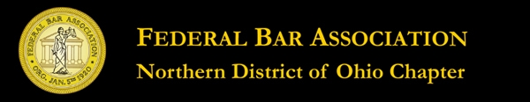

WHAT YOU NEED TO KNOW ABOUT…..
Wednesday, August 29, 2012
3.O New Lawyer Training General Credit Hours
An application for accreditation as an approved NLT CLE program has been submitted to the Supreme Court of Ohio

Seminar Agenda

1:00 p.m..- Registration

1:30 p.m.- Criminal Law
Duane Deskins
Assistant US Attorney
General Crimes Division
Northern District of Ohio

2:00 p.m.- Collecting A Judgment
Scott Weltman
Weltman, Weinberg & Reis Co., LPA

2;30 p.m.- Personal Injury
Peter Weinberger
Spangenberg, Shilbley & Liber LLP

3:00 p.m.- Break

3:15 p.m. -Antitrust
J. Philip Calabrese
Squire Sanders & Dempsey

3:45 p.m.- Bankruptcy
Hon. Arthur I. Harris
United States Bankruptcy Court
US District Court ND Ohio

4:15 p.m. – Employment Law
Hon. Annette Garner Butler
Cuyahoga County Common Pleas Court

4:45 p.m.- Conclusion

