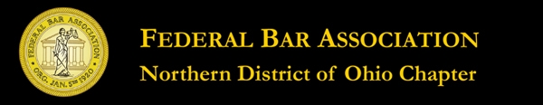

WHAT THEY DIDN’T TEACH YOU
IN LAW SCHOOL
Tuesday, August 28, 2012
3.0 New Lawyer Training General Credit Hours
An application for accreditation as an approved NLT CLE program has been submitted to the Supreme Court of Ohio

Seminar Agenda

1:30 p.m.- Registration

2:00 p.m.- Getting Comfortable in Federal Court
As a New Lawyer
Richard W. Cline
McDonald Hopkins LLC

2:30 p.m.- Handling Case Management and Status
Conferences
Dennis R. Rose
Hahn Loeser & Parks LLP

3:00 p.m.- Handling Mediations
R. Jeffrey Pollack
McDonald Hopkins, LLC

3:30 p.m.- Break

3:45 p.m. – A Look at the Local Rules and Trial
Orders of the Judges
Aaron H. Bulloff
Kadish, Hinkel & Weibel

4:15 p.m. –Picking Your Jury
George S. Coakley
Remingr Co. LPA

4:45 p.m. – How to Represent Clients Effectively
Hon. Dan A. Polster
United States District Court-ND Ohio

5:15 p.m. - Conclusion

