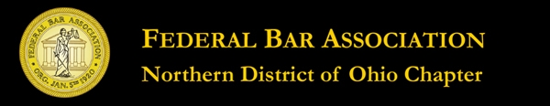

PROFESSIONAL LAW OFFICE MANAGEMENT
CLIENT FUNDS MANAGEMENT

Wednesday, August 29, 2012
3.0 New Lawyer Training General Credit Hours
An application for accreditation as an approved NLT CLE program has been submitted to the Supreme Court of Ohio

Seminar Agenda

8:30 a.m.- Registration

9;00 a.m. – Law Office Management
Benjamin M. Cooke
Cooke & Co. LPA

10:00 a.m. Professionalism- Conflicts of Interest/Waivers
Frank R, DeSantis
Partner, Thompson Hine LLP

10:30 a.m. – Break

10:40 a.m. – Client Funds Management
What to Do and Not to Do
Maura L. Hughes
Partner, Calfee Halter & Griswold LLP

11:40 a.m. – Professionalism –Establishing Professional
Relationships/Networking
Rick Santangelo
Asso. Dir. Business Development
Thompson Hine LLP

12:10 p.m. - Conclusion

